AP2 Report

Firstly, numbers were randomly generated and distributed to act as coordinates to be plotted. The data was then split into two datasets, with 75% set aside for training and 25% for testing. The network that was built includes an input and output dimension of 2, with 6 hidden units. Using a Backpropogation trainer, the number of iterations to be run was set to 15.

When the code was run, the test had an accuracy of 0.692, a precision of 1.0 and a recall of 0.34188034188. The error percentage of the training data came out to be 38.00% and the error percentage of the test data was 30.80%

Training Data

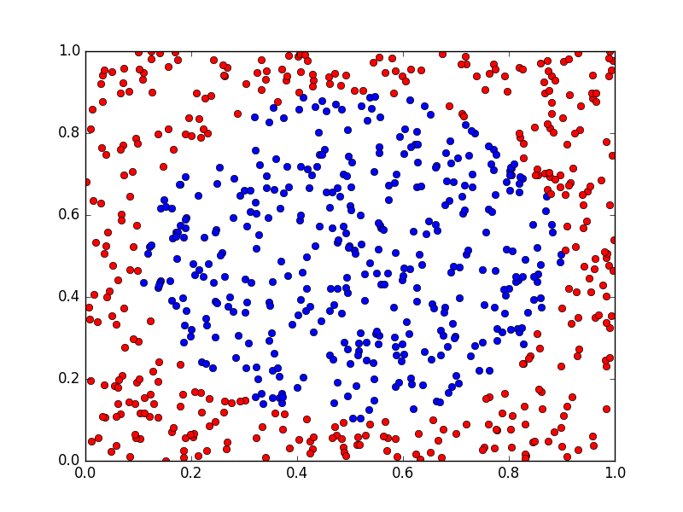

Test Data

